Lab 10: Terrestrial Arthropods
In this lab, we will be using pictures included at the end of this week’s PowerPoint as well as some videos. Please complete this worksheet and turn in via Blackboard. Make sure to read Chapter 12: The Rise of the Animal Kingdom AND Chapter 13: Terrestrial Arthropods in the lab manual.
- There will be several drawings/sketches required in this lab. Please make sure to preview your document before submitting on Blackboard to ensure it is still legible. (Hint: You can export your Microsoft Word file as a PDF and submit the assignment as a PDF and this should eliminate any overlapping of pictures.)

Investigation 6: Crustaceans (Chapter 12)
Part 1: Crayfish Appendages
- Watch the following video that explores the appendages of a crayfish. Using the information from the video and figure 12.9 in the lab manual, answer the following questions. How many segments are in the abdomen? How many appendages are there? Don’t forget about the mouthparts and antennae! https://illinois.pbslearningmedia.org/resource/7d86b548-5bdf-4596-82a8-6f858da2eb82/detailed-crayfish-dissection-video-part-i/
The abdomen has six clear segments. The crayfish has eight pairs of appendages. The first three pairs are called maxillipeds and are used for holding food. The fourth pair is the chelipeds (large claws) used for defense and capturing prey. The other four pairs have 1 pair of walking legs each.

Part 2: Crayfish Dissection
- Watch the following video about the internal anatomy of a crayfish. Note the arrangements of the gills at the base of each leg. How does this arrangement facilitate respiration? Draw a diagram of the digestive system of the crayfish. https://illinois.pbslearningmedia.org/resource/63e59559-eaac-46ce-b56b-134356e0984b/dissection-101-detailed-crayfish-dissection-part-ii/
The arrangement of the gills at the base of each leg facilitates respiration because water is allowed to run through the feather-like gills underneath the carapace, which is aligned backwards. This alignment allows water to run in a channel over the gills, releasing carbon dioxide and picking up oxygen. The feather-like structure increases their surface area for increased oxygen collection.
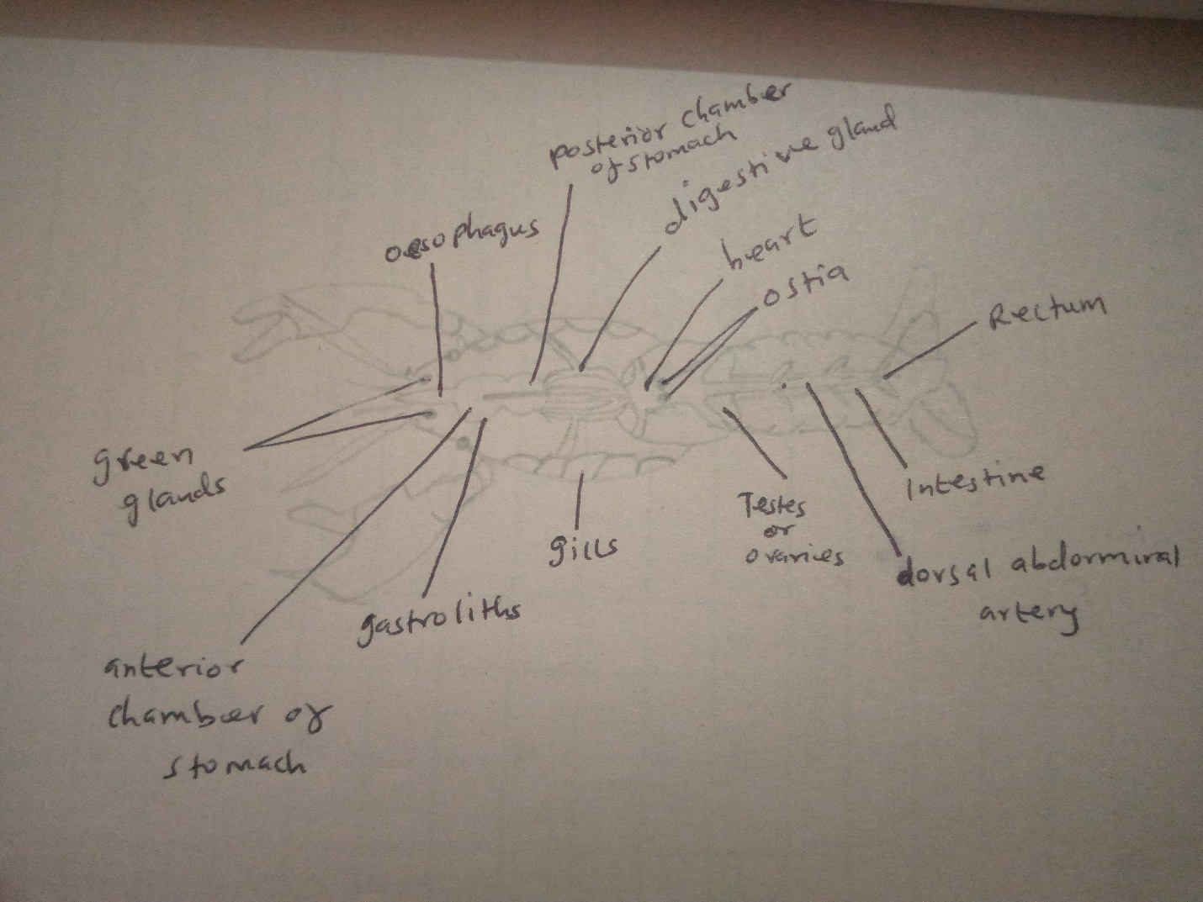
Figure 1: digestive system of a crayfish.

Part 3: Crustacean Diversity
- Using the images in the PowerPoint, observe the different species of crustaceans. Compare them to the above investigations on the crayfish. What are some similarities that you notice? Each picture needs to be accompanied by a short 2-3 sentences minimum explanation.
Thera are several similarities between the crustaceans in the PowerPoint and crayfish. Comparing crayfish to crabs, they both have four pairs of legs. Another similarity is that they have legs with joints. They have a hard-outer shell (exoskeleton), which is used for protection. They have many appendages, more than seven pairs. These appendages are used to aid in walking, swimming, feeding, respiration, and defense.

Investigation 1: Chelicerates (Chapter 13)
Part 1: Horseshoe Crabs
- Watch the following video featuring a horseshoe crab as well as observe the pictures in the PowerPoint. How does it compare to the crustaceans you saw in the previous investigation? Are there antennae? Can you see any chelicerae? https://www.youtube.com/watch?v=aJb-u-1LPzY&ab_channel=ZebHallock

Compared to crustaceans, the horseshoe crab has a hard exoskeleton used for protection. They have legs with joints. Chelicerates and crustaceans have two body segments (cephalothorax and the abdomen). Crustaceans have two pairs of sensory antennae, which are absent in chelicerates. Crustaceans and chelicerates have a pair of chelicerae.

Part 2: Arachnid Diversity
- Survey the different pictures of arachnids in the PowerPoint. Compare them to the horseshoe crab. How are they different/similar? Draw one of the arachnids as an example, making sure you label the chelicerae. Each picture needs to be accompanied by a short 2-3 sentences minimum explanation.
The similarities between the horseshoe crab and spiders (arachnids) are that both have chelicerae in the place of mandibles. The difference between the horseshoe crab and other arachnids is that the former has its legs attached to its mouth while the latter has its legs attached to the cephalothorax.
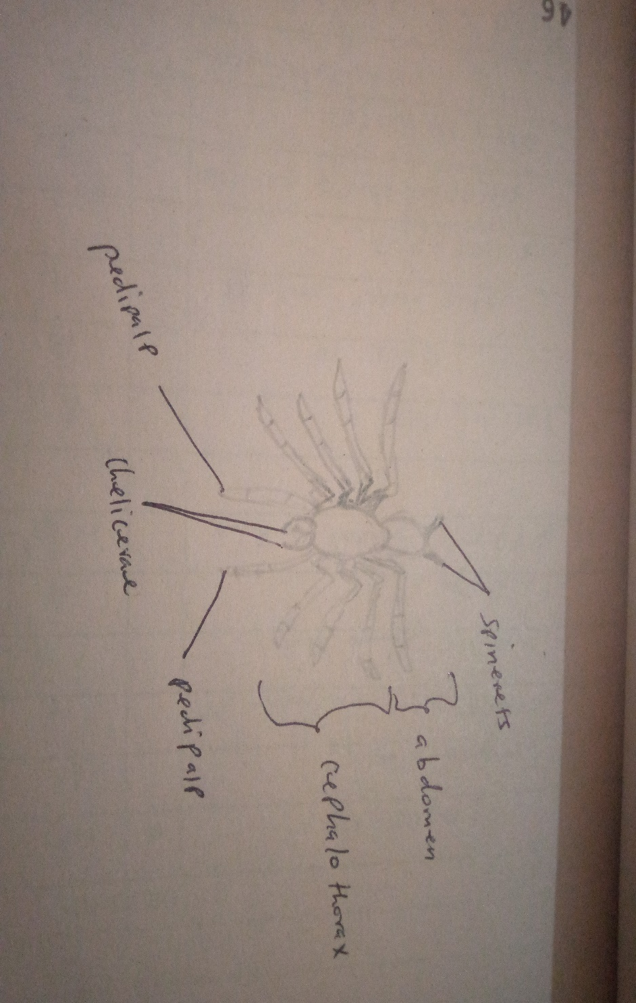
Figure 2: spider (arachnid).

Investigation 2: Insects (Chapter 13)
Part 1: Insect Life Cycles
- Watch the following video of a Hercules beetle undergoing metamorphosis. What kind of metamorphosis does it display? Draw each major stage and label which stage it is. https://www.youtube.com/watch?v=AFbu21AGSho&ab_channel=NatGeoWILD

The kind of metamorphosis displayed by the Hercules beetle is a complete metamorphosis (egg, larval, pupal, and adult).
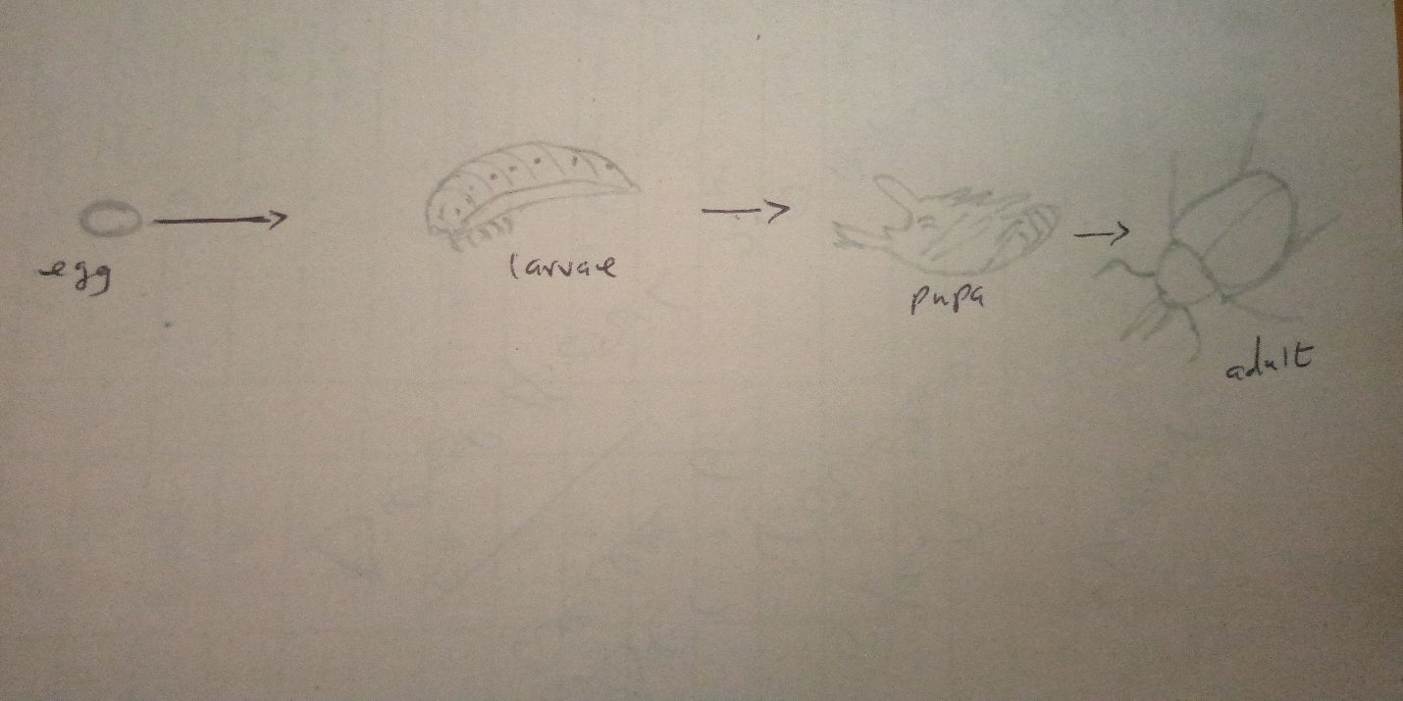
Figure 3: complete metamorphosis of Hercules beetle.

Part 2 : Insect Diversity
- Survey the different insect pictures on the PowerPoint. Note how their appendages, including their mouthparts, are modified for different lifestyles. Compare them to the arachnids above. How can you tell the difference between an insect and an arachnid?
There are many differences and similarities between insects and arachnids. Differences can include, insects have 3 pairs while arachnids have 4 pairs of legs. Insects use mandibles while arachnids use chelicerae for feeding. Insects have three distinct body parts (head, abdomen, and thorax) while arachnids have two parts (cephalothorax and abdomen. I can tell the difference between insects and arachnids by counting their body parts, looking at their mouth parts, or counting the pair of legs.

